Relationship and Sex Education (RSE) Policy
January 2022

Introduction

This policy has been written in consultation with Directors, staff, parents and pupils at Park House School (PHS). The completed policy statement is available to parents. Relationship and Sex Education (RSE) is lifelong learning about physical, moral and emotional development. It is about understanding the importance of marriage for family life, stable and loving relationships, respect, love and care. It is also about the teaching of sex, sexuality, and sexual health. It is not about the promotion of sexual orientation or sexual activity.

School context

Park House School is a small, independent and specialist school which aims to support young people with communication and interaction difficulties, typically found in children
with a diagnosis of ASD, achieve their full potential in all areas of their development.
Students attending Park House School are aged between 6 and 19 years old.

Statutory Requirements

All schools in England and Wales have a legal responsibility to provide a ‘sex education’ programme, as outlined in the Children and Social Work Act 2017. In teaching Relationships and Sex Education (RSE), schools must have regard to the guidance issued by the secretary of state as outlined in section 403 of the Education Act 1996. Schools also have a responsibility to keep an up-to-date written statement of the policy they choose to adopt and this must be available to parents. This policy takes full account of the school’s legal obligations and the latest DfE (Department for Education) guidance ‘Relationships and Sex Education Guidance’.

Aim

The aims of relationships and sex education at our school are to:

- Promote the spiritual, cultural, mental and social well-being of all students
- Prepare students for the responsibilities of adult life
- To present information in a sensitive, balanced, objective and developmentally appropriate manner
- To present information in an accessible, visual, practical and suitably differentiated way
- To empower all students to understand they have the right to say no to touch which makes them feel uncomfortable, using their preferred method of communication.
- Provide a framework in which sensitive discussions can take place
- Prepare pupils for puberty, and give them an understanding of sexual development and the importance of health and hygiene
- Help pupils develop feelings of self-respect, confidence and empathy
- Create a positive culture around issues of sexuality and relationships
- Teach pupils the correct vocabulary to describe themselves and their bodies

The 3 elements of RSE are:
Knowledge and understanding

  - Learning and understanding physical development at appropriate stages.
  - Understanding human sexuality, sexual health, emotions and relationships.
  - Learning about contraception and a range of local and national sexual health advice, contraception and support services.
  - Learning the reasons for delaying sexual activity and the benefits to be gained from such delay.
  - The avoidance of unplanned pregnancy.

Attitudes and values

  - Learning the importance of values and individual conscience and moral considerations.
  - Learning the value of family life, marriage, and stable and loving relationships for the nurture of children.
  - Learning the value of respect, love, and care.
  - Exploring, considering, and understanding moral dilemmas.
  - Developing critical thinking as part of decision making.

Personal and social skills

  - Learning to manage emotions and relationships confidently and sensitively.
  - Developing self-respect and empathy for others.
  - Learning to make choices based on an understanding of difference and with an absence of prejudice.
  - Developing an appreciation of the consequences of choices made.
  - Managing conflict.
  - Learning how to recognise and avoid exploitation and abuse.

Approach to RSE within PHS

At PHS, to teach RSE, we use a range of resources, including but not limited to:
- BBC Active Sex and Relationship Education PSHE pack
- CGP Science workbooks
- ASDAN Sex and Relationship Education Short Course
- Basic Skills for life – Health Matters
- PSHE Association programme of study.

PHS carefully assesses each resource they propose to use to ensure they are appropriate for the age and maturity of pupils and sensitive to their needs. Where relevant, PHS uses resources that are medically accurate. PHS also considers the expertise of the main subject associations who often quality assure third-party resources. PHS aims to ensure that when they consult parents, they provide examples of the resources they plan to use. This can be reassuring for parents and enables them to continue the conversations started in class at home.

Accessibility

Relationships and Sex Education should be available to all students, irrespective of gender, ethnic background, physical or cognitive ability. Due to the complexity of needs and range in developmental stages of the pupils at Park House School, a multi-disciplinary team of professionals (Occupational Therapist, Speech and Language Therapist, Psychologist and Teacher) will work together to ensure the delivery of RSE content is developmentally appropriate to the individual needs of each student. The broad pathways at Park House School are Pre-Formal, Semi-Formal and Formal learners, although we recognise and celebrate that students can have a blended approach of these pathways due the complexity of their needs. The paragraphs below provide an overview of the content delivered in each of the pathways.

Pre-formal

Children learn about the concept of male and female and about young animals. In ongoing PSHE work they develop skills to form friendships, manage their feelings (though the Zones of Regulation curriculum) and develop and understanding of how to have safe relationships with others. This will include empowering students to say no to touch which makes them feel uncomfortable through using their preferred method of communication. They will also work on life skills and personal hygiene.
Semi Formal

Through work in Science children learn about the life cycles of some animals, understand the idea of growing from young to old and learn that all living things reproduce. They learn about the importance of personal hygiene to maintain good health. In RE and Citizenship children reflect on family relationships, different family groups and friendship. They learn about rituals and traditions associated with birth, marriage and death and talk about the emotions involved.
They begin to cooperate with others in work and play and begin to recognise the range of human emotions and ways to deal with them. They also learn about personal safety.

Formal

In Science children build on their knowledge of life cycles and learn about the basic biology of human reproduction system. Pupils are taught about the physical, emotional and social changes at puberty, which include personal hygiene. In RE and Citizenship they continue to develop an understanding of relationships within a family, between friends and the community and that there are different patterns of friendship. They will develop skills needed to form relationships and to respect other people’s emotions and feelings. They will consider how to make simple choices and exercise some basic techniques for resisting pressures.

By the end of Key Stages 3 and 4 (formal) pupils will have had opportunities to gain knowledge and skills necessary to build and maintain healthy relationships including sexual relationships. They will also have considered their own and others’ attitudes towards relationships and sex as they begin to develop positive values which will guide them in making healthy choices in their future relationships. By the end of Key Stage 4, where developmentally appropriate, students will have had the opportunity to develop their understanding of the following areas:

- Positive relationships
- Relationship values
- Forming and maintaining respectful relationships
- Consent
- Contraception and parenthood
- Bullying, abuse and discrimination
- Social influences

The needs of young people and the role of schools

The DfE statutory guidance ‘Relationships Education, Relationships and Sex Education (RSE) and Health Education’ (2019) states that, ‘The aim of RSE is to give young people the information they need to help them develop healthy, nurturing relationships of all kinds, not just intimate relationships. It should enable them to know what a healthy relationship looks like and what makes a good friend, a good colleague and a successful marriage or other type of committed relationship.’ PHS has a key role, in partnership with parents/carers, in providing RSE.
Research has shown that young people who feel good about themselves, and are knowledgeable and confident about sex and relationships, are more likely to be more discerning in their relationships and sexual behaviours and to have fulfilling relationships.

Morals and Values Framework

Our approach to RSE will be conducted within a clear morals and values framework based on the following principles:

- the value of stable and loving relationships
- respect, understanding and empathy towards others who may have diverse backgrounds, cultures, sexuality, feelings, and views
- the development of relationships, including sexual relationships, based on mutual consent, rather than coercion
- the right not to be abused by other people or be taken advantage of
- the right of people to follow their own sexuality, within legal parameters

We also believe that pupils have an entitlement to:

- age and circumstance appropriate RSE
- access to help from trusted adults and helping services

RSE involves consideration of a number of sensitive issues about which different people may hold strong and varying views. PHS approach to RSE will be balanced and take account of, and be sensitive to, different viewpoints but will not be based on personal bias.

Inclusion

As stated in the DfE ‘Relationships Education, Relationships and Sex Education (RSE) and Health Education’ (2019) document, ‘Relationships Education, RSE and Health Education must be accessible for all pupils...’
PHS will tailor the content and teaching to meet the specific needs of our pupils at different developmental stages. As with all teaching for these subjects, we will ensure that their teaching is sensitive, age-appropriate, developmentally appropriate and delivered with reference to the law.

To achieve this PHS approach to RSE will take account of:

- Ethnic and cultural diversity

Different ethnic and cultural groups may have different attitudes to RSE. The school will consult pupils and parents/carers about their needs, take account of their views and promote respect for, and understanding of, the views of different ethnic and cultural groups.

- Varying home backgrounds

We recognise that our pupils may come from a variety of family situations and home backgrounds. We will take care to ensure that there is no stigmatisation of children based on their home circumstances.

- Sexuality

Pupils should be taught the facts and the law about sex, sexuality, sexual health and gender identity in an age-appropriate and inclusive way. All pupils should feel that the content is relevant to them and their developing sexuality. Sexual orientation and gender identity should be explored at a timely point and in a clear, sensitive and respectful manner. When teaching about these topics, it must be recognised that young people may be discovering or understanding their sexual orientation or gender identity. There should be an equal opportunity to explore the features of stable and healthy same-sex relationships. This should be integrated appropriately into the RSE programme, rather than addressed separately or in only one lesson

- Special educational needs or disabilities

We will take account of the fact that pupils may have learning, emotional or behavioural difficulties or physical disabilities that result in particular RSE needs. Teaching and resources will be differentiated as appropriate to address the needs of these children in order for them to have full access to the content of sex and relationship education.

The teaching programme for Sex and Relationship Education

We intend that all pupils will experience a programme of RSE at a level which is appropriate for their age and physical and emotional development.

- Contraceptive advice to KS4 pupils

Pupils will be taught, in the context of sexual intimacy and safer sex, that intercourse should always involve using a condom. Questions about forms of contraception will be answered accurately and honestly within the pupil's ability to understand. If pupils need further personal advice about contraceptive use, counselling and support will be sought from appropriate agencies and personnel.

- A whole school approach

A whole school approach will be adapted to RSE that actively involves the whole school community. All groups who make up the school community have rights and responsibilities regarding RSE.

In particular:

- The Senior Leadership Team (SLT) will support the provision, development and ensure the implementation of RSE in line with this policy by providing leadership and adequate resourcing.

- The designated RSE Coordinator within the School will maintain an overview of RSE provision and have overall responsibility for its development. This will include:
  - keeping up to date with developments and good practice
  - developing the provision to meet student’s needs
  - providing support and resources for staff
  - arranging staff training
  - liaison with outside agencies and
  - monitoring and evaluation

- All teaching are involved in the school’s RSE provision. Some teach RSE through explicit PSHE lessons and some through science and other curriculum areas. All teachers play an important pastoral role by offering support to pupils. Any member of the multi-disciplinary team can be approached by a pupil who experiences a difficulty regarding sex or relationships issues. Teachers will be consulted about the schools' approach to RSE and aided in their work by provision of resources, background information, support, and advice from experienced members of staff and access to appropriate training.

- Key-workers may be involved in a supportive role in some RSE lessons and also play an important, informal pastoral support role with pupils. They will have access to information about the RSE programme and be supported in their pastoral role

- Directors have responsibilities for school policies. They will be consulted about the RSE provision and policy.

- Parents/carers have a legal right to view this policy and to have information about the school’s RSE provision. They also have a legal right to withdraw their children from dedicated sex education lessons if they wish (see section 7.8). The school will seek, and take account of, parent/carer views and endeavour to adopt a partnership approach with parents/carers. The school’s approach to RSE will encourage dialogue between parents/carers and their children.

- The therapy team also play a key role in supporting the teacher in RSE both in terms of advice, input into lessons, provision of pastoral support for pupils and resources.

- Outside agencies and speakers may be involved in inputting to RSE lessons and as points of referral as support services for pupils. PHS will only work with agencies and speakers who are appropriate to pupil needs. We shall work in partnership with them and jointly plan their work within the school. PHS will also promote relevant helping agencies that pupils can access.

- Pupils have an entitlement to age and circumstance appropriate RSE and pastoral support. They will be actively consulted about their RSE needs and their views will be central to developing the provision.

Place in the curriculum

The main RSE programme will be delivered in a developmentally appropriate manner through a blended approach of:
- Explicit PSHE lessons
- Pastoral support through 1:1 tutorials
- Social stories
- Through role play and play-based learning experiences
- Explicit science lessons

Content and learning objectives

The RSE programme is delivered in a progressive manner so that issues are explored in greater depth as pupils mature. The following areas of content are addressed in the following sections according to the pupil's ability, age and understanding. All pupils are planned for on an individual basis. Park House School are members of the PSHE Association and the association’s SEND planning framework is used to ensure coverage and progression in knowledge within the area of RSE, as shown in the tables below.

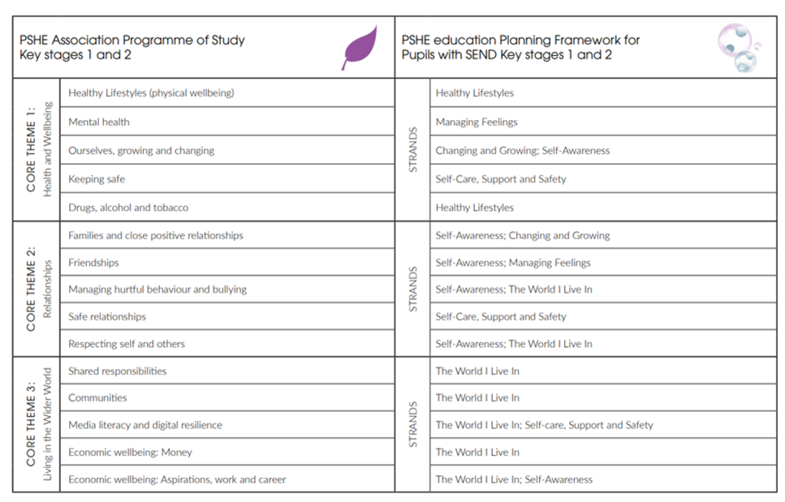

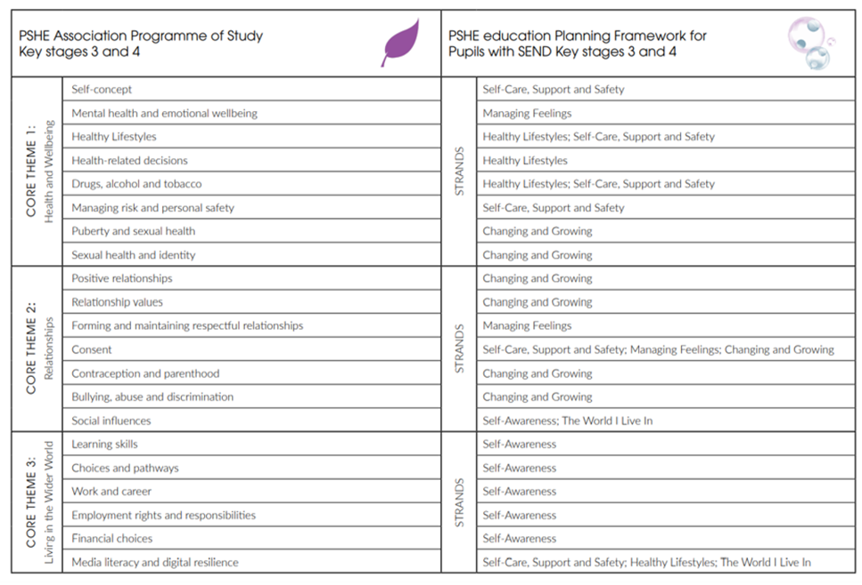

Answering pupils’ questions

PHS believes that pupils should have opportunities to have their genuine questions answered in a sensible and matter-of-fact manner. However, occasionally a pupil may ask a particularly explicit, difficult or embarrassing question in class. Teachers will use their skill and discretion to decide about whether to answer questions in class and, if so, how. They will establish clear parameters of what is appropriate and inappropriate in class by discussing ground rules with pupils and by taking an approach that encourages pupils to be mature and sensible.

If a teacher does not know the answer to a question, they will acknowledge this and suggest that they and pupils research the answer to the question later. If a question is too explicit or inappropriate to answer in class at that moment, teachers will acknowledge it and attend to it later with the pupil who asked it. If a question is too personal teachers will remind pupils about the ground rules and if necessary, point out appropriate sources of support. This may involve referring the pupil back to their parent/carer, school health advisor or young person’s health drop-in service for an answer.
If a teacher is concerned that a pupil is at risk of sexual abuse, they will follow the school’s child protection procedures. In some cases, teachers may wish to use an anonymous question box in lessons where pupils can write down questions that are later answered by the teacher.

Terminology

Ofsted guidance recommends that it is important for children to learn the language associated with body parts so that children are able to talk to health professionals. Therefore, teachers will use the anatomically correct language for body parts, while acknowledging common terms used by some people.

Monitoring, evaluation and assessment

The Leadership Team gather evidence for the monitoring and evaluation of the RSE programme by means of ensuring a carefully sequenced long-term plan is in place to ensure coverage of key skills and knowledge in a sensitive and developmentally appropriate way, lesson observations, monitoring lesson plans and gathering feedback from teachers, keyworkers and pupils. Feedback is obtained from group discussions with teachers, keyworkers and pupils. Any staff development needs will also be identified.

In line with the school’s assessment policy, pupil’s progress within the area of PSHE and RSE will be assessed termly by the multi-disciplinary team of professionals. Where developmentally appropriate, formal standardised assessment methods may be used to determine a student’s progress in terms of scientific knowledge. Where standardised/formal assessment is deemed to not be developmentally appropriate or in the student’s best interests, professional judgement will be used coupled with a robust moderation process to ensure accurate recording of progress made.

The coverage (as detailed in the tables above) is mapped over a 2-year rolling programme and students will be supported to gain a deeper understanding of each strand each time the content is encountered. The scale below is used to support teachers in assessing the depth of each student’s knowledge in each strand.

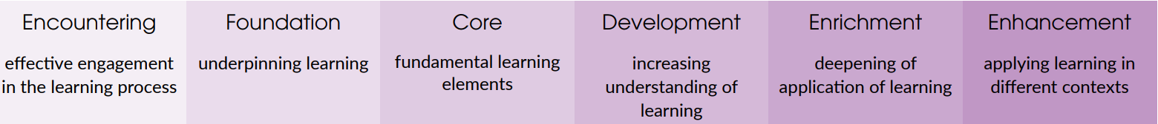

Parental concerns and withdrawal of pupils

In primary education from September 2020:

- Parents will not be able to withdraw their children from any aspect of Relationships Education or Health Education (which includes learning about the changing adolescent body and puberty).
- Parents will be able to withdraw their children from any aspects of Sex Education other than those which are part of the science curriculum. (Note that sex education will not be statutory in primary schools, however the new statutory guidance makes clear that schools should still provide a programme of age-appropriate sex education)
- Head teachers in primary schools must grant requests to withdraw a pupil from sex education, other than where it is part of the science curriculum (although the guidance makes clear that good practice is ‘likely to include the head teacher discussing with parents the benefits of receiving this important education and any detrimental effects that withdrawal might have on the child’).
- Where pupils are withdrawn from sex education, schools should document the process and will have to ‘ensure that the pupil receives appropriate, purposeful education during the period of withdrawal.’

In secondary education from September 2020:

- Parents will not be able to withdraw their child from any aspect of Relationships Education or Health Education.
- Parents will be able to withdraw their child (following discussion with the school) from any or all aspects of Sex Education, other than those which are part of the science curriculum, up to and until three terms before the age of 16.
- After that point, the guidance states that ‘if the child wishes to receive sex education rather than be withdrawn, the school should make arrangements to provide the child with sex education during one of those terms.’
- Where pupils are withdrawn from sex education, schools should document the process and will have to ‘ensure that the pupil receives appropriate, purposeful education during the period of withdrawal.’

Full details of the RSE programme at PHS are available upon request. The school will inform parents/carers when aspects of the RSE programme are taught and will provide opportunities for parents/carers to view the resources being used.

We will work in active partnership with parents/carers, value their views and keep them informed about the RSE provision. If a parent/carer has any concerns about the RSE provision we will take time to address their concerns and allay any fears they may have. If any parents/carers decide to withdraw their child we shall work with them and their child to explore possible alternative provision.

Any parent wishing to withdraw their child is encouraged to make an appointment with the Principal to discuss the matter. Any complaints about the content or delivery of RSE should be addressed to the Principal.

The nature of support available to pupils

PHS takes its role in the promotion of pupil welfare seriously. Staff endeavour to make themselves approachable and to provide a caring and sensitive pastoral support for pupils in a number of ways. Staff may be approached for help on an individual basis and through the tutorial/ pastoral system. They offer a listening ear and, where appropriate, information and advice. The Teaching team and Learning Mentors offer a health and support service to pupils. For PHS, there are regular timetabled 1:1 pastoral tutorials allocated to each pupil. The School will keep up to date about the development of local services and national helplines for young people and promote their existence to pupils and endeavour to form working relationships with local agencies that are relevant to student needs.

Confidentiality and informing parents/carers

We are aware that some parents find it hard to cope with their children’s sexual development, and are happy for PHS to take the initiative. We will take every opportunity to inform and involve parents and carers:

- by placing sex education on the agenda at the relevant SLT and Development Group Meeting
- by including RSE in the Home/School Partnership Agreement
- by inviting parents to a meeting where resources are available, and their use explained

School staff cannot promise absolute confidentiality if approached by a pupil for help. Staff must make this clear to pupils. Child protection procedures must be followed when any disclosures about abuse are made. It is very rare for a pupil to request absolute confidentiality. If they do, in situations other than those involving child protection issues, staff must make a careful judgement about whether or not a third party needs to be informed.

This judgement will be based upon:

- The seriousness of the situation and the degree of harm that the pupil may be experiencing
- The pupil’s age, maturity and competence to make their own decisions

Where it is clear that a pupil would benefit from the involvement of a third party, staff should seek the consent of the pupil to do so. If appropriate, staff might inform the third party together with the pupil. Unless clearly inappropriate, pupils will always be encouraged to talk to their parent/carer.

Under 16s’ entitlement to confidential health advice and treatment

RSE lessons will inform pupils of their entitlement to seek confidential help, including contraceptive and sexual health advice and treatment, and they will be taught about how they can access local services for this both inside and outside school.

